Statement of Findings for
Executive Order 11990

Protection of Wetlands

Big Cypress National Preserve - Addition
General Management Plan

Big Cypress National Preserve, Florida

Recommended:____________________________________________________________
Superintendent, Big Cypress National Preserve Date

Concurred:________________________________________________________________
Chief, Water Resources Division Date

Approved: ________________________________________________________________
Director, Southeast Region Date

Table of Contents

INTRODUCTION 1
PURPOSE AND NEED FOR THE ACTION 2
Justification for Use of Wetlands 2
ALTERNATIVES 3
Alternative A: No Action (Continue Current Management) 3
Alternative B 3
Preferred Alternative 4
Alternative F 4
DESCRIPTION OF AFFECTED WETLANDS 5
Inventory and Condition of Wetlands Affected by Proposed ORV Trail Stabilization 6
General Condition of the Areas Described 32
Wetland Functions and Values 34
ADVERSE IMPACTS TO WETLANDS FROM SELECTED ALTERNATIVE ACTIONS 37
Qualitative Impacts 37
Quantitative Impacts 38
WETLAND IMPACT AVOIDANCE, MINIMIZATION, AND COMPENSATION 39
Efforts to Avoid and Minimize Impact 39
Proposed Compensatory Mitigation Measures 40
Mitigation Success Criteria 40
ON-SITE MONITORING 42
Monitoring Methodology 42
Wildlife Monitoring 42
Photographic Documentation 42
MONITORING REPORTS 42
LONG-TERM MAINTENANCE 43
WORK SCHEDULE PLAN 43
COMPLIANCE 43
Clean Water Act – Section 404 44
State of Florida Requirements 44
National Environmental Policy Act 44
CONCLUSION 44
REFERENCES CITED 44

Figures

Figure 1. National Wetland Inventory vegetation types in the Northeast Addition 6
Figure 2. Vegetative communities in the Northeast Addition (Welch and Madden 1999) 7
Figure 3. Reclassification of vegetative communities in the Northeast Addition 8
Figure 4. Areas in the Northeast Addition where wetland trail stabilization will be required. 9
Figure 5. Trail Stabilization Area 1 10
Figure 6. Trail Stabilization Area 2 11
Figure 7. Trail Stabilization Area 3 12
Figure 8. Trail Stabilization Area 4 13
Figure 9. Trail Stabilization Area 5 14
Figure 10. Trail Stabilization Area 6 15
Figure 11. Trail Stabilization Area 7 16
Figure 12. Trail Stabilization Area 8 17
Figure 13. Trail Stabilization Area 9 18
Figure 14. Trail Stabilization Area 10. 19
Figure 15. Trail Stabilization Area 11. 20
Figure 16. Trail Stabilization Area 12 21
Figure 17. Trail Stabilization Area 13. 22
Figure 18. Trail Stabilization Area 14. 23
Figure 19. Trail Stabilization Area 15 24
Figure 20. Trail Stabilization Area 16 25
Figure 21. Trail Stabilization Area 17 26
Figure 22. Trail Stabilization Area 18. 27
Figure 23. Trail Stabilization Area 19 28
Figure 24. Trail Stabilization Area 20 29
Figure 25. Typical stabilized trail plan and cross-sectional views 30
Figure 26. Profile of a palustrine wetland system 34
Figure 27. Proposed mitigation site for ORV trail stabilization impacts 41

Tables

Table 1. Wetland types (Cowardin et al. 1979) affected by ORV trail stabilization 30
Table 2. Wetland acres to be filled from ORV trail stabilization. 38
Table 3. Preliminary UMAM functional assessment of wetland impacts. 39
Table 4. Wetland mitigation restoration and monitoring schedule. 43

INTRODUCTION

Big Cypress National Preserve (BICY) was authorized by an act of Congress on October 11, 1974, (Public Law 93-440) with a boundary surrounding 582,000 acres. That act was amended on April 29, 1988, when Congress passed the Big Cypress National Preserve Addition Act (Public Law 100-301) to expand BICY by 147,000 acres. The expansion area is referred to as the Addition and consists of two separate areas, the Northeast Addition and the Western Addition.

The National Park Service (NPS) finalized a General Management Plan for the original Preserve in 1991. That plan did not address the Addition, as those lands were in private ownership until most of them were transferred to the NPS in 1996. In 2010 the NPS completed a General Management Plan/Wilderness Study/Off-Road Vehicle Management Plan/Environmental Impact Statement (GMP) for the Addition, and a Record of Decision (ROD) was signed in 2011. The Addition is closed to motorized recreation.
The 1974 enabling act and the Addition Act provide for motorized recreational access to BICY subject to regulation. The selected GMP alternative documented in the ROD will provide approximately 130 miles of primary off-road vehicle (ORV) trails in the Addition, and many of these trails are located in wetlands. The ROD stated that the NPS will analyze wetland functions and values affected by NPS actions in order to prepare a Wetlands Statement of Findings (WSOF), as required by NPS policy. The ROD further determined that ORV use associated with the GMP would likely be the primary focus of a WSOF for the Addition and that no ORV use, ORV trail development, or other actions with wetland impacts would be implemented or allowed until the appropriate wetland policy requirements were met.

The ORV trail network proposed in the Addition will only include existing trails in areas of previous wetland disturbance. All of the trails that will become part of the Addition network have been in place since before the NPS acquired the Addition, and many have been continuously used by the NPS, other governmental agencies, landowners, researchers, and tribal members. As such, ORV trail designation and use in the Addition will not result in new wetland impacts requiring a WSOF in order to meet NPS policy. BICY recognizes, however, that concentrated use of the existing trail network will require stabilization in some locations in order to sustain use and that some of these areas may require deposition of fill in wetlands. In order to fulfill its commitment to protect wetlands and develop wetland impact avoidance, minimization and compensation measures, BICY has exceeded the NPS policy standard and prepared this WSOF for those areas to be stabilized within the proposed ORV trail network. In addition, any deposition of fill and wetlands mitigation will be done in accordance with permits issued by the responsible state and federal regulatory agencies.

Prior to design, permitting, and construction of any facility proposed in the GMP not related to the ORV trail system, BICY will prepare the appropriate NEPA compliance documentation and WSOF, if applicable, in accordance with NPS policy.

PURPOSE AND NEED FOR THE ACTION

The GMP is needed to provide direction on how the NPS will manage visitor access, resources, and its operations within the Addition. The scope of the GMP is confined to the Addition only. The GMP is also needed to meet the requirements of the National Parks and Recreation Act of 1978 and NPS policy, which mandate development of a GMP for each unit in the national park system.

The GMP is the basic document for managing the Addition for the next 15 to 20 years. The purposes of the plan are to:

- Confirm the purpose, significance, and special mandates of the Addition.

- Clearly define resource conditions and visitor uses and experiences to be achieved in the Addition.

- Provide a framework for NPS managers to use when making decisions about how to best protect Addition resources, how to provide quality visitor uses and experiences, how to manage visitor use, and what kinds of facilities, if any, to develop in the Addition.

- Ensure that this foundation for decision-making has been developed in consultation with interested stakeholders and adopted by the NPS leadership after an adequate analysis of the benefits, impacts, and economic costs of alternative courses of action is completed.

Justification for Use of Wetlands

The selected action described in the ROD will designate approximately 130 miles of primary trails and an undetermined amount of secondary trails for ORV use in the Addition. All but approximately one mile of primary trails will occur in the Northeast Addition. The trail designation takes into consideration the requirements of the Addition’s enabling legislation; i.e., the Addition Act, which directed the NPS to provide for recreation opportunities while preserving the Addition’s resource values. The selected action will result in the filling of 10.63 acres of wetlands, all in the Northeast Addition, as a result of primary trail stabilization; secondary trails will not require stabilization. The ROD contains a map of conceptual primary trails that were recommended based on field evaluations during the GMP development. The locations of these trails were determined taking into account the need to avoid wetlands to the maximum practicable extent while meeting the intent and direction of the enabling legislation. Wetland impacts that cannot be avoided will be minimized. Compensation for unavoidable impacts to wetlands will be based on a functional analysis of the impacted wetlands and proposed mitigation, which is consistent with the NPS no-net-loss wetlands policy.

ALTERNATIVES

The GMP described four alternatives, including the NPS’s preferred alternative, for future management of the Addition. The alternatives, which are based on BICY’s purpose, significance, and special mandates, presented different ways to manage resources and visitor use and improve facilities and infrastructure in the Addition. The four alternatives included the no-action alternative (alternative A), which described the continuation of current management direction, and three action alternatives (alternative B, the preferred alternative, and alternative F). Additional alternatives were considered but dismissed from further detailed analysis. These dismissed alternatives were presented, along with the rationale for dismissing them, in the “Alternatives, Including the Preferred Alternative” discussion in chapter 2 of the GMP.

Alternative A: No Action (Continue Current Management)

The no-action alternative described a continuation of existing management and trends in the Addition and provided a baseline for comparison in evaluating the changes and impacts of the other alternatives. The NPS would continue to manage the Addition as it is currently being managed. The Addition would remain closed to motorized recreation, and only minor new construction would be authorized to accommodate visitor access, primarily for hiking and biking. Existing operations and visitor facilities would remain in place. Natural ecological processes would be allowed to occur, and restoration programs would be initiated where necessary. No wilderness would be proposed for designation. Impacts on wetlands would be attributed primarily to the retention and maintenance of existing facilities, such as roads, grades, and trails. Impacts would include vegetation loss and alteration of soils, which would result in permanent effects on wetland size and integrity. Indirect impacts, such as increased runoff and sedimentation, would also occur. NPS efforts to reestablish natural ground contours and restore soil integrity would have positive effects on wetlands. Because there would be no motorized recreation, there would be no recreational ORV trails and hence no direct wetland impacts from trail stabilization.

Alternative B

The concept for management under alternative B would be to enable visitor participation in a wide variety of outdoor recreational experiences. It would maximize motorized access, provide the least amount of proposed wilderness of all the action alternatives, and develop limited new hiking-only trails. New visitor and operations facilities along the Interstate-75 (I-75) corridor would also be provided. Impacts on wetlands would be attributed primarily to the development and maintenance of facilities. The development of new facilities, such as trails, trailheads, access points, and specific improvements to develop Deep Lake into a day use area would result in permanent loss of wetlands. The designation and use of ORV trails would also adversely impact wetland function and integrity. Maintaining roads, grades, and trails could impact wetlands. Impacts from these activities would include vegetation loss and alteration of soils, which would result in permanent effects on wetland size and integrity. Indirect impacts, such as increased runoff and sedimentation, would also occur. The extent of direct wetland impacts resulting from trail stabilization would be similar to the preferred alternative, i.e., 10-11 acres.

Preferred Alternative

The preferred alternative would provide diverse frontcountry and backcountry recreational opportunities, enhance day use and interpretive opportunities along road corridors, and enhance recreational opportunities with new facilities and services. This alternative would maximize ORV access, provide a moderate amount of wilderness, provide nonmotorized trail opportunities and new camping opportunities, and develop a partnership approach to visitor orientation. New visitor and operations facilities along the I-75 corridor would also be provided. Impacts on wetlands would be attributed primarily to the development and maintenance of facilities. The development of new facilities, such as trails, trailheads, access points, and specific improvements to develop Deep Lake into a day use area would result in permanent loss of wetlands. The designation and use of ORV trails could also adversely impact wetland function and integrity. Maintaining roads, grades, and trails could impact wetlands. Impacts from these activities would include vegetation loss and alteration of soils, which would result in permanent effects on wetland size and integrity. Indirect impacts, such as increased runoff and sedimentation, would also occur. Direct impacts to wetlands resulting from trail stabilization would total 10.63 acres.

Alternative F

Alternative F would emphasize resource preservation, restoration, and research while providing passive recreational opportunities with limited facilities and support. This alternative would provide the maximum amount of wilderness, no ORV use, and minimal new facilities for visitor contact along I-75. Impacts on wetlands would be attributed primarily to the retention and maintenance of existing facilities, as well as from the removal of facilities. Maintaining roads, grades, and trails could impact wetlands. Impacts would include vegetation loss and alteration of soils, which would result in permanent effects on wetland size and integrity. Indirect impacts, such as increased runoff and sedimentation, would also occur. NPS efforts to reestablish natural ground contours and restore soil integrity would have beneficial effects on wetlands. Removing and restoring Nobles Grade would improve the hydrologic function and connectivity of wetlands in the Northeast Addition as well as create new wetlands where the road is removed and restored. Because there would be no motorized recreation, there would be no recreational ORV trails and hence no direct wetland impacts from trail stabilization.

The preferred alternative was developed through a process known as Choosing by Advantages. The relative advantages of each preliminary alternative were compared to four factors. These factors included provision for visitor opportunities, protection and restoration of resources, preservation of wilderness values, and provision for effective NPS operations and public safety. The highest ranking advantages were analyzed and considered for inclusion in the development of the preferred alternative. The preferred alternative, although not the alternative with the least wetland impacts, nevertheless incorporated the most advantages in view of the four factors.

After release of the draft GMP and following a public comment period, the preferred alternative was revised to include adjustments to eligible and proposed wilderness and a reduction in miles of ORV trails. The revised preferred alternative was published in the final GMP and selected for implementation as documented in the ROD. The NPS concluded that the preferred alternative met the Addition’s and BICY’s enabling legislative requirements to preserve, conserve, and protect natural and cultural resources while providing for public enjoyment. Although the selected alternative is not the alternative with the least wetland impact, it nevertheless best balances the NPS’s need to provide high-quality visitor experiences and protect Addition resources.

DESCRIPTION OF AFFECTED WETLANDS

Wetlands in the Northeast Addition have been mapped by the U.S. Fish and Wildlife Service under the National Wetlands Inventory (NWI) program. The wetlands identified on the NWI maps are classified according to Cowardin et al. (1979), which separates wetland types primarily by hydrologic conditions, vegetation, and water chemistry.

To assess and quantify the wetlands and wetland functions that will be affected by the ORV trail stabilization associated with the NPS’s selected alternative, a map of the proposed ORV trail system was overlaid onto NWI and vegetation cover maps of the Northeast Addition.
Figures 1 through 24 present the vegetative communities of the Northeast Addition as a whole as well as those for each of the 20 proposed stabilization sites. Figure 1 shows only the broad NWI wetland types, not the individual classifications. Because the NWI maps have been found to be 50 to 70% remiss in defining wetlands, this coverage was not used for analysis purposes. Instead, wetlands were delineated and classified by use of a vegetation classification system created for south Florida national parks (Welch and Madden 1999). Figure 2 shows the variety of vegetative habitats mapped in the Northeast Addition under this classification system. The Welch and Madden system was revised by BICY staff in 2000 by reclassifying the data into 12 vegetative community types. This classification of vegetative communities, represented in Figure 3, uses the information produced by Welch and Madden but combines many of the categories to depict areas of more general vegetative communities. Determination of wetlands in which proposed trail stabilization will occur was done by James N. Burch, PhD., PWS (Professional Wetland Scientist) 1748, Supervisory Botanist, Big Cypress National Preserve. The Welch and Madden geographic information system (GIS) coverage was matched with the proposed trail network and stabilization areas as well as 2009 Collier County aerial photographs to allow the wetland scientist to evaluate both the described vegetative community as well as the vegetation as photographed. The intersections of the 20 stabilization areas and vegetative communities were checked against aerial photographs to assure maximum accuracy in wetland determination. Multiple maps were produced to allow large-scale representation of the proposed stabilization areas. Figure 4 provides a view of the 20 areas in relation to the Northeast Addition as a whole. Large-scale maps of the individual areas can be found in figures 5 – 24, along with descriptions of the Welch and Madden (1999) and Cowardin et al. (1979) wetland types to be filled. The wetland types are summarized in Table 1. Figure 25 is a cross-section of a typical stabilized trail.

Inventory and Condition of Wetlands Affected by Proposed ORV Trail Stabilization

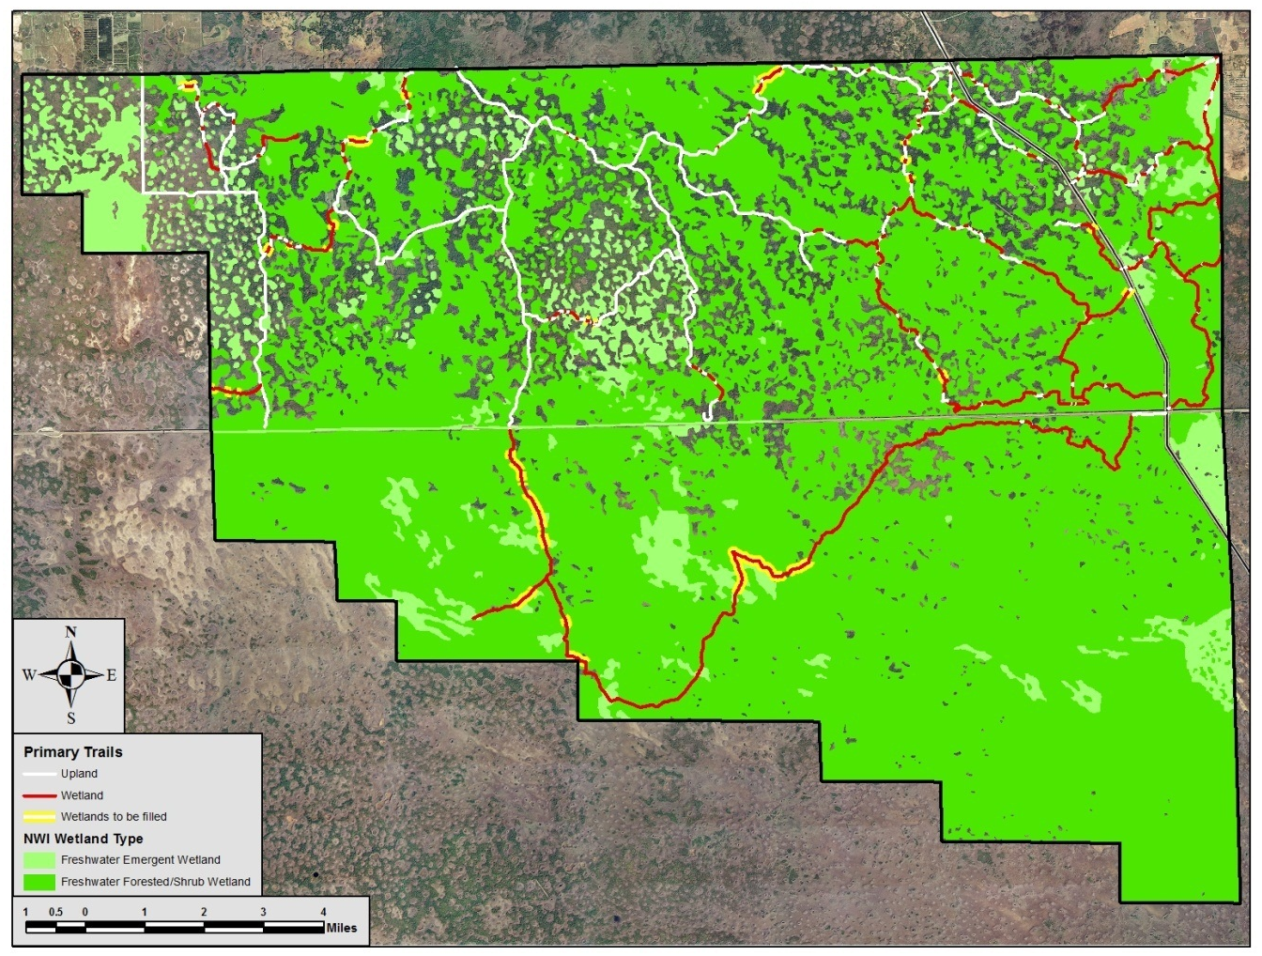
Figures 1-24 illustrate the vegetation and wetland communities of the Northeast Addition and potential changes to these communities from the proposed ORV trail stabilization. It should be noted that many trails are indicated as uplands even though they appear to be in wetlands; this is because they will utilize elevated roads constructed before BICY’s establishment.
Figure 1. National Wetland Inventory vegetation types in the Northeast Addition.

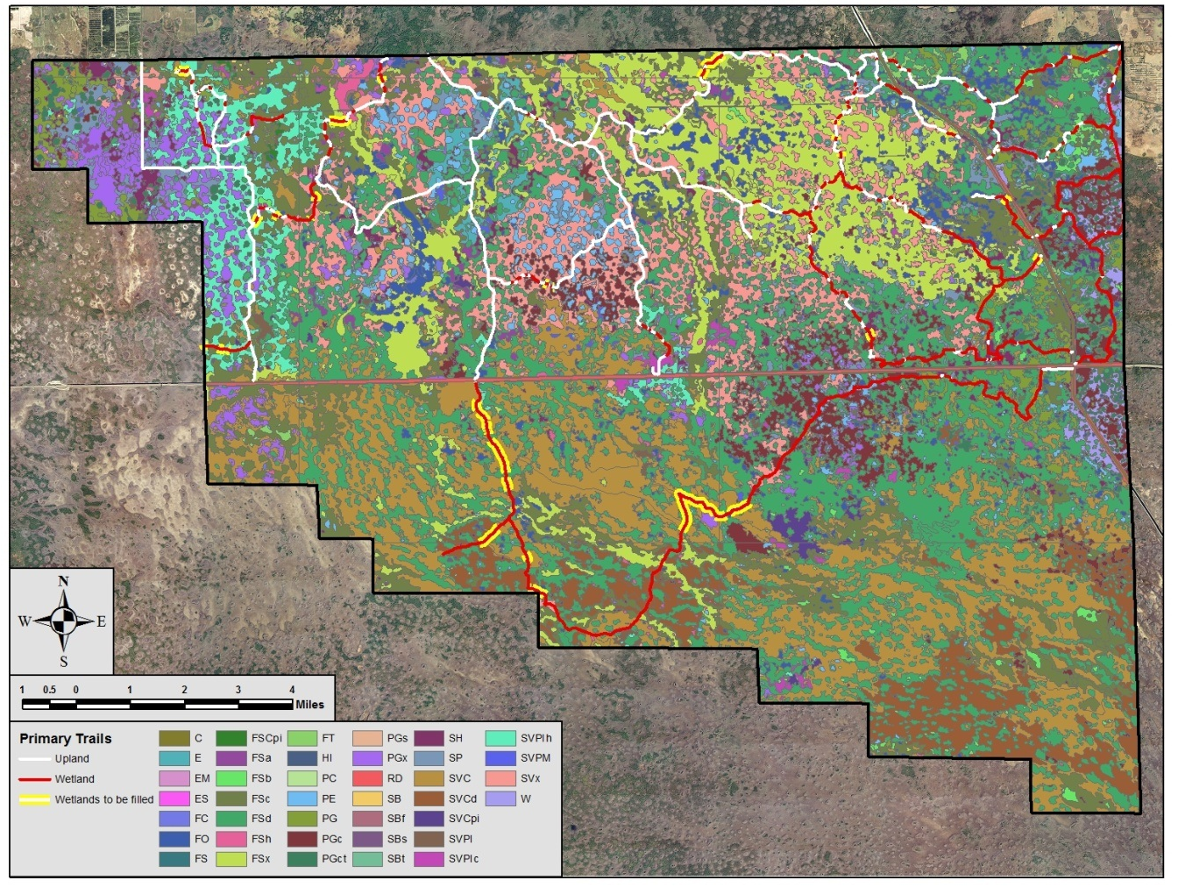
Figure 2. Vegetative communities in the Northeast Addition (Welch and Madden 1999).

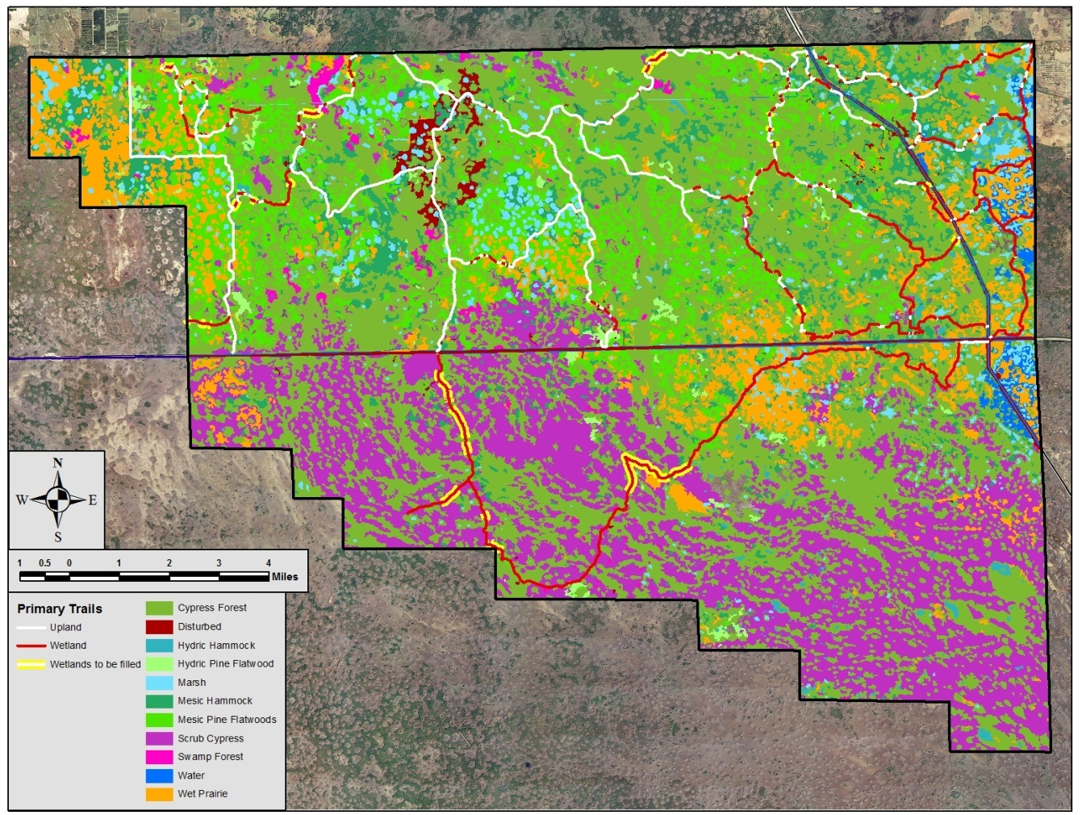

Figure 3. Reclassification of vegetative communities in the Northeast Addition. This classification uses the information produced by Welch and Madden (1999) but combines many of the categories to depict areas of more general vegetative communities.
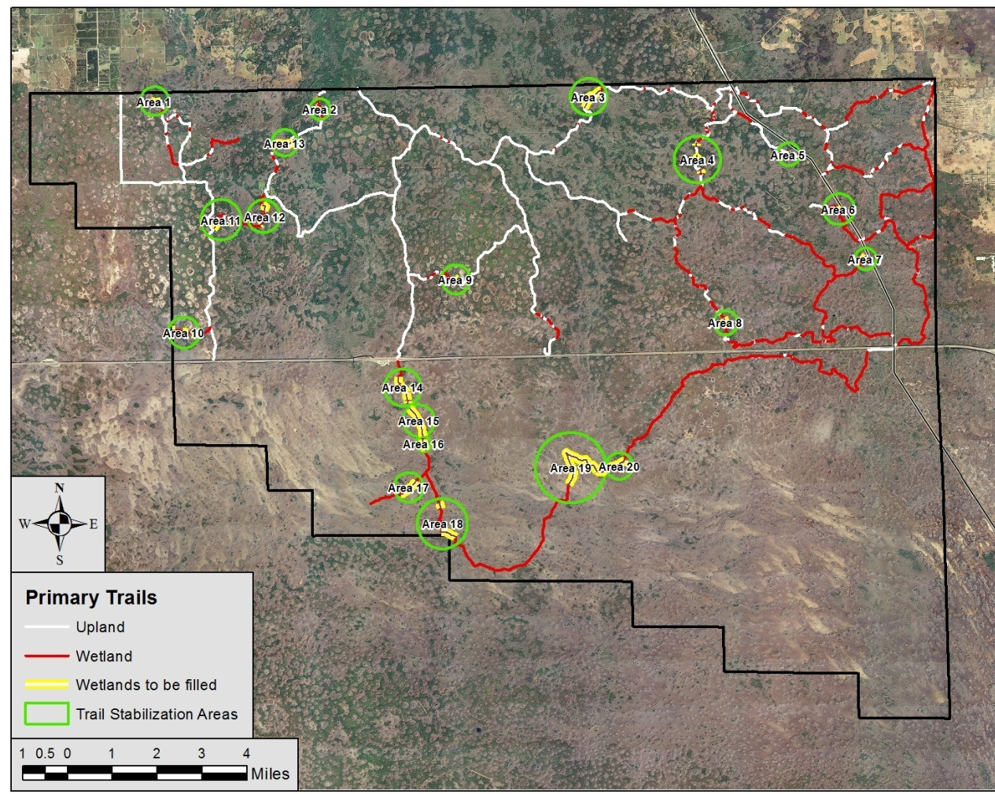
Figure 4. Areas in the Northeast Addition where wetland trail stabilization will be required.

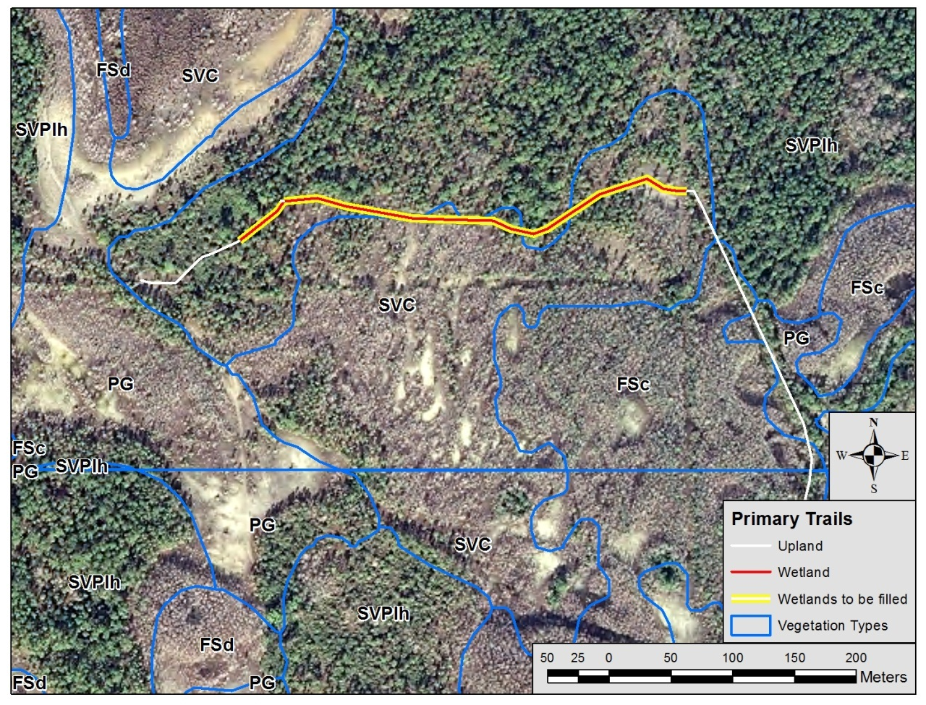
Figure 5. Trail Stabilization Area 1. Wetland communities proposed for stabilization are SVC: cypress savanna (PFO2C, palustrine bald cypress in graminoid prairie, seasonal inundation) and SVPIh: slash pine with hardwoods (PFO4A, palustrine slash pine).
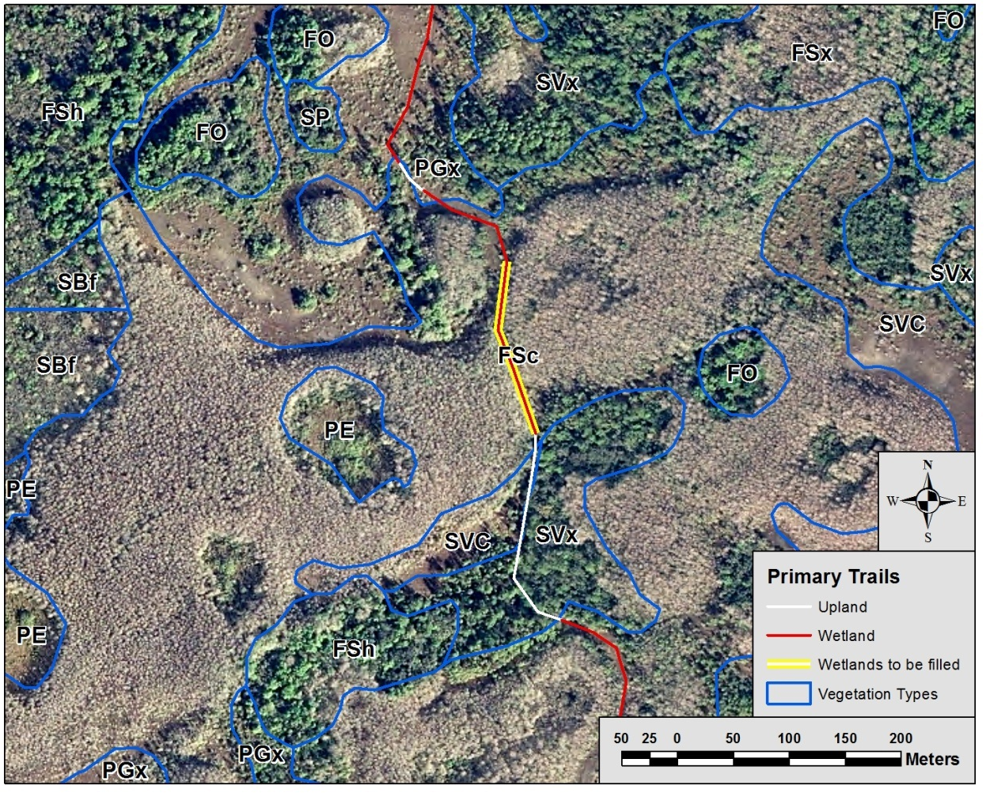
Figure 6. Trail Stabilization Area 2. Wetland community proposed for stabilization is FSc: cypress strand (PFO2C, palustrine bald cypress in graminoid prairie, seasonal inundation).
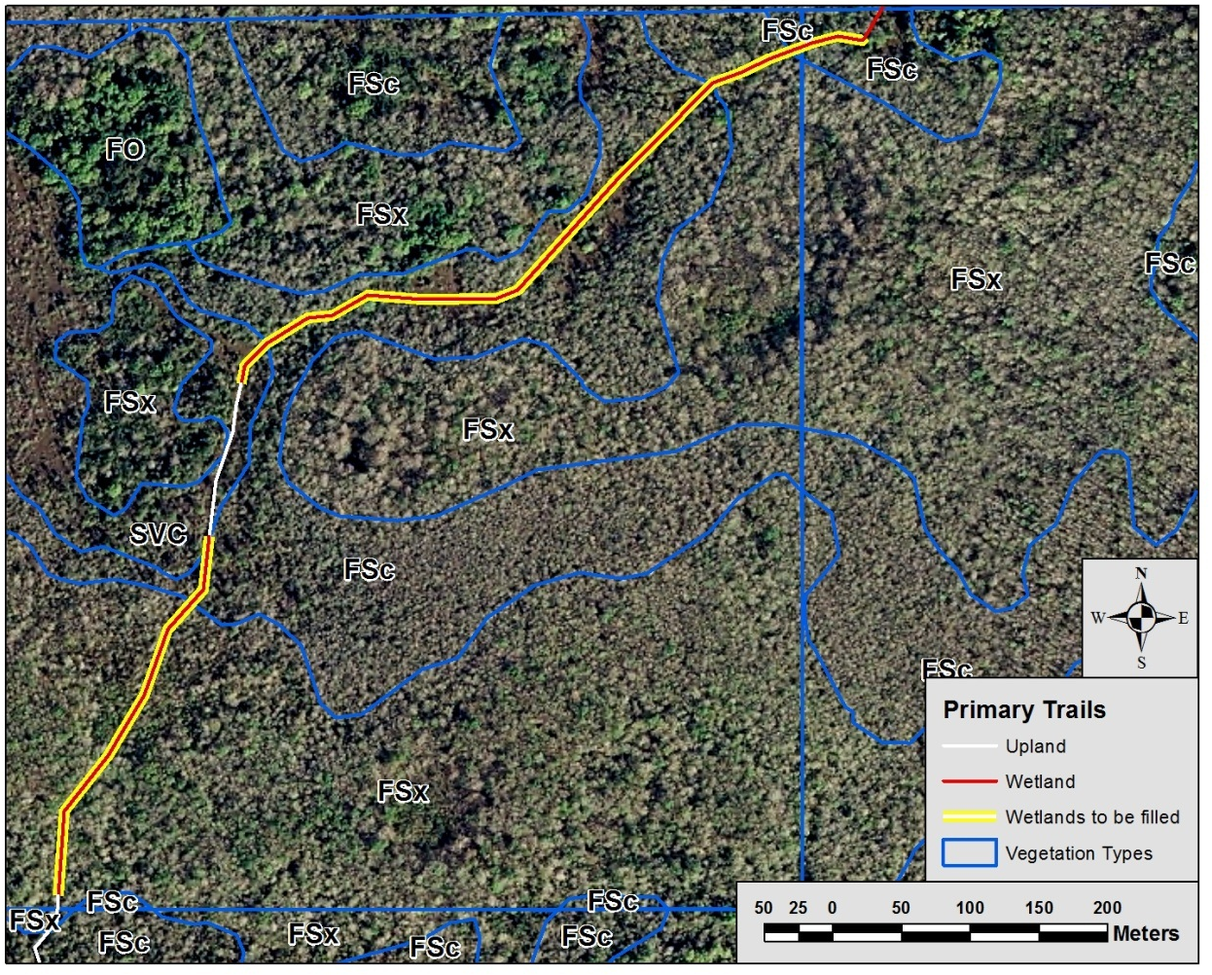
Figure 7. Trail Stabilization Area 3. Wetland communities proposed for stabilization are FSc: cypress strand (PFO2C, palustrine bald cypress in graminoid prairie, seasonal inundation), FSx: cypress mixed hardwoods (PFO2C, palustrine mixed forest, seasonal inundation), and SVC: cypress savanna (PFO2C, palustrine bald cypress in graminoid prairie, seasonal inundation).

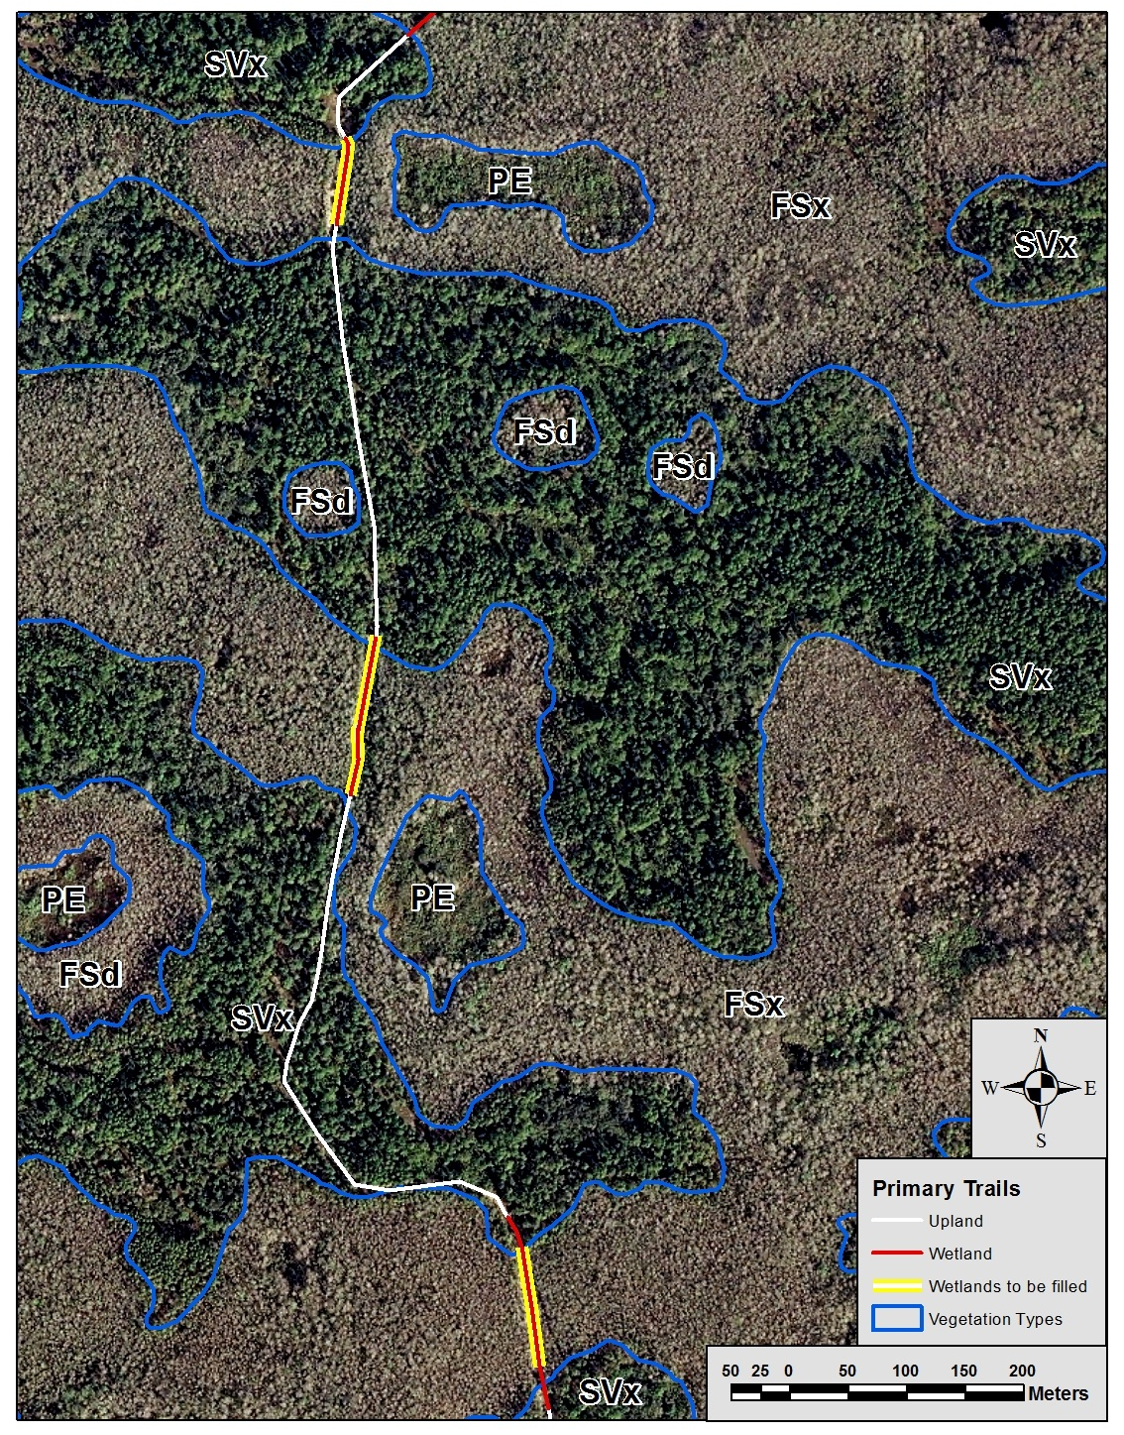
Figure 8. Trail Stabilization Area 4. Wetland community proposed for stabilization is FSx: cypress mixed hardwoods (PFO2C, palustrine mixed forest, seasonal inundation).
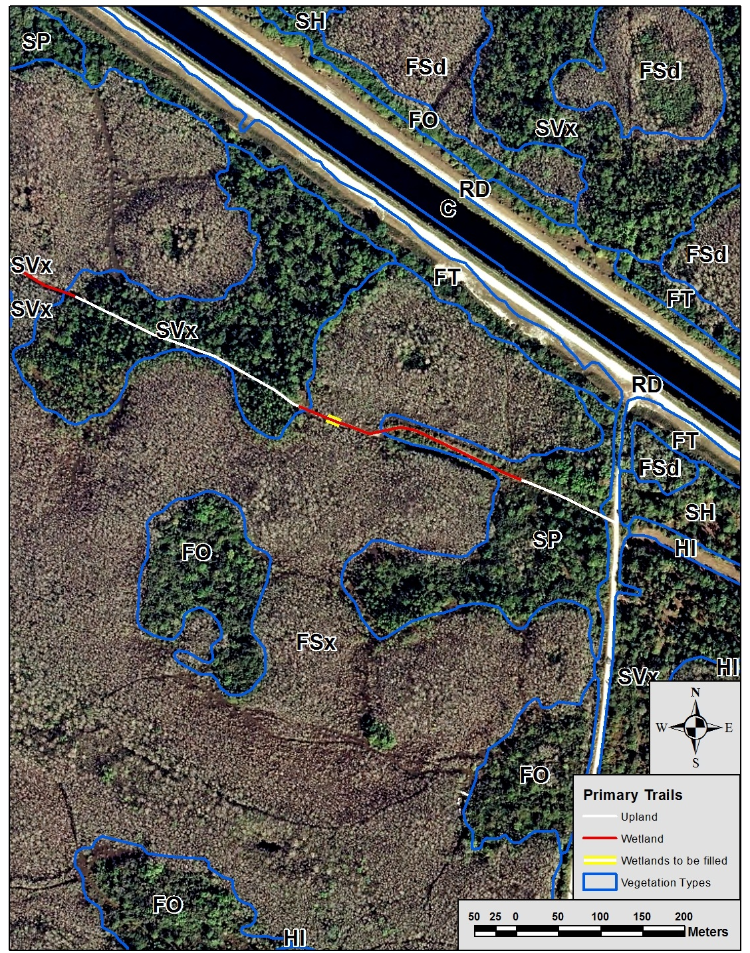
Figure 9. Trail Stabilization Area 5. Wetland community proposed for stabilization is FSx: cypress mixed hardwoods (PFO2C, palustrine mixed forest, seasonal inundation).
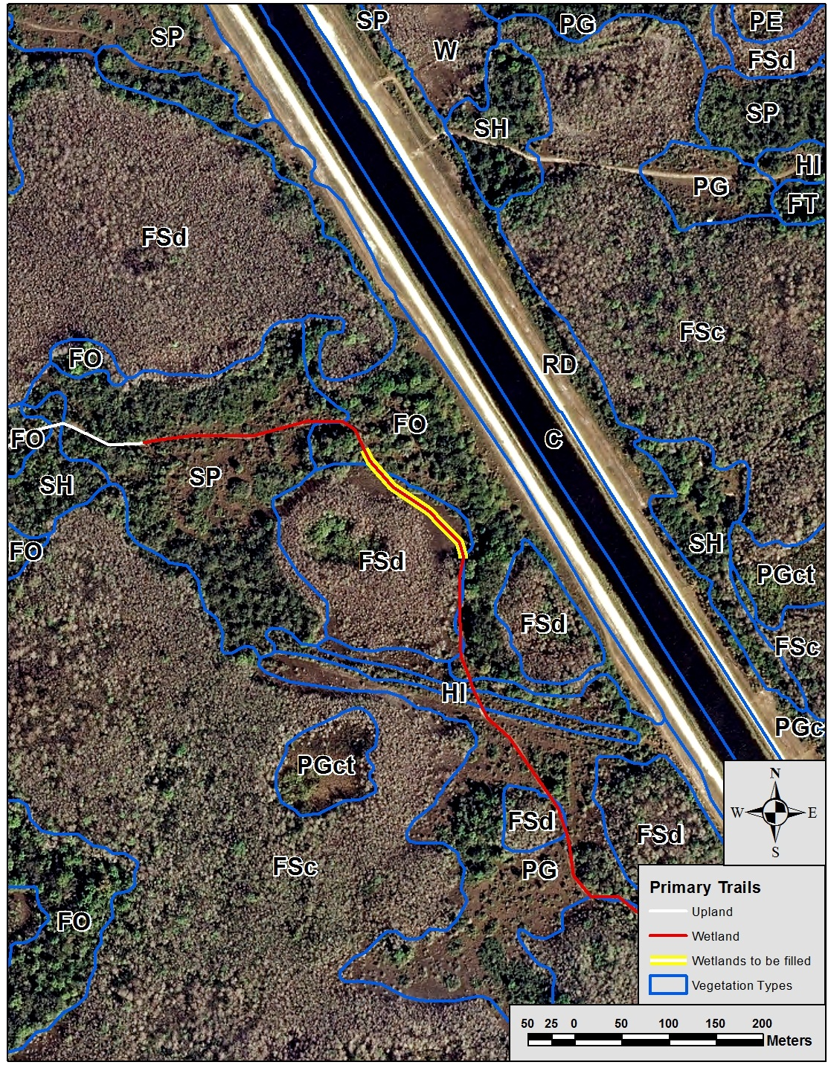
Figure 10. Trail Stabilization Area 6. Wetland communities proposed for stabilization are FSd: cypress domes/heads (PFO2C, palustrine bald cypress forest, seasonal inundation) and FO: oak sabal forest (PFO3A, palustrine mixed forest, temporary inundation).

