Glacier
Scoping Newsletter #1
National Park Service
U.S. Department of the Interior
Glacier National Park
Sperry Chalet, the Next 100 Years
Environmental Assessment (EA)

Background
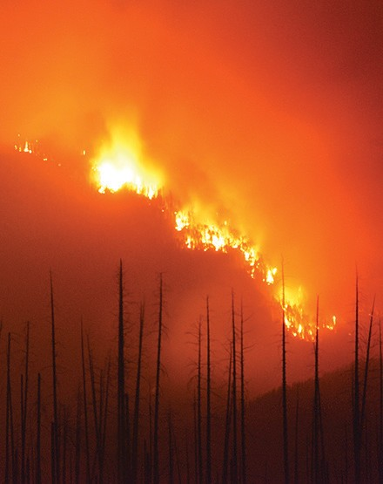

Significance of Sperry Chalet

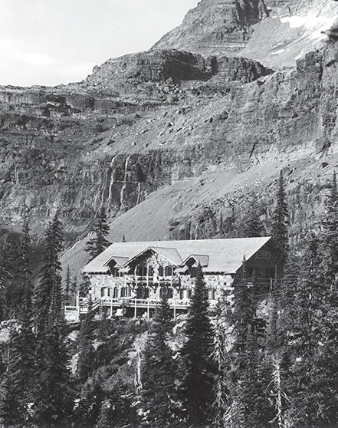
The Sprague Fire began with a lightning strike in Glacier National Park on August 10, 2017 and escaped initial attack tactics (helicopter water drops and insertion of personnel). A longer term suppression and containment effort ensued.

The Sperry Chalet dormitory building burned during an ember storm from the Sprague Fire on August 31, 2017. Firefighters and four helicopters on scene were successful in defending four out of the five structures that compose the Sperry Chalet Complex, including the historic dining hall, and the non-historic employee quarters, trails cabin, and toilet facility.

The Sperry Chalet complex is located six miles by trail from the Going-to-the-Sun Road and lies just below Sperry Glacier and Comeau Pass. The dining hall and the dormitory are the two buildings in the complex that are contributing to the Great Northern Railway Buildings Architecture in the Parks National Historic Landmark. Combined, these buildings are the largest collection of Swiss Chalet-style buildings in the United States. “It is the only instance in which one distinct architectural style is used on such a massive scale for a
concession development and the only instance in which a European system of hostelries built a day’s hike or ride apart is used.” (Speech by Theodore Roosevelt in Osawatomie, Kansas, August 31, 1910)
Notwithstanding the fire, NPS believes that Sperry still retains historic integrity because it is a “preservable entity” and because good documentation exists about its construction and recent condition that can be used to support proposed future actions. Photographs taken in February 2018 confirmed that the four walls and chimneys are still standing and that the stabilization effort to date has been successful.

Sperry Chalet has served visitors to Glacier National Park continuously since 1914 except between 1992 and 1999. The Sperry Chalet Dormitory had an overnight capacity of 50 persons, and operated for a two month season annually. In addition to the historic dormitory and dining hall, the complex includes toilet/washroom facilities and two bunkhouses for NPS utility and trail crew staff. The current 10-year concession contract
is held by Belton Chalets, Inc. which is under the ownership of a family who has operated both Sperry and Granite Park Chalets for three generations.

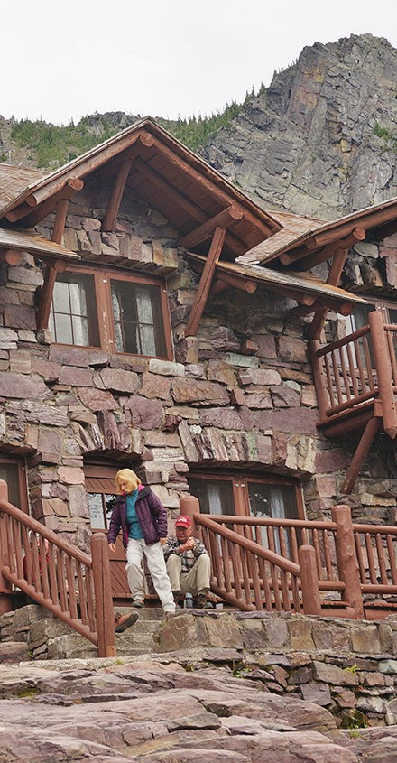
Sperry Chalet Dormitory Stabilization Efforts
An initial structural assessment of the Sperry Chalet Dormitory (B756) and Sperry Chalet Dining Hall (B797) was performed on September 12, 2017. The Sperry Chalet Dining Hall sustained minimal damage to the roofing and decking, but none of the other structures in the complex were damaged. Emergency stabilization of the dormitory’s four remaining walls
and two chimneys was completed in October 2017. The stabilization measures were based on recommendations from a contract structural engineer and NPS historic preservation specialists.

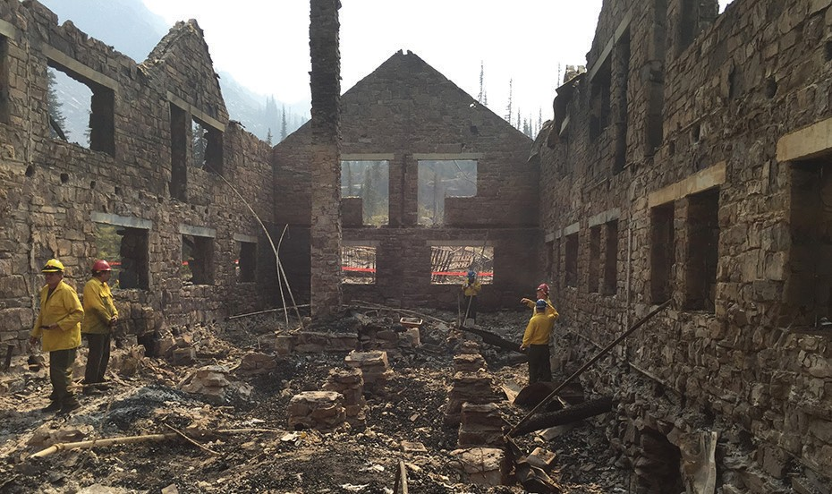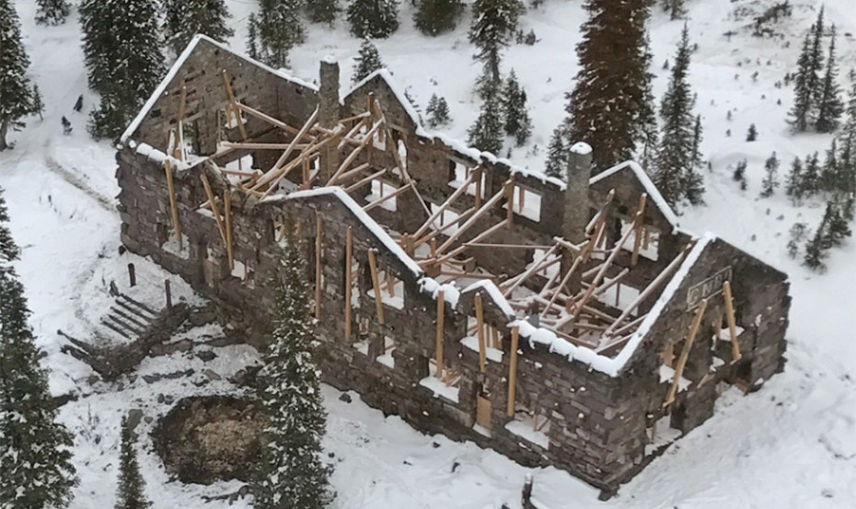

Proposed Action: Objectives
Restore the Sperry Chalet experience for the next 100 years and continue to provide a remote backcounty chalet experience surrounded by recommended wilderness in Glacier National Park.

Protect a National Historic Landmark.

Reduce impacts to natural and cultural resources while restoring the Chalet experience.

Concerns and Issues
- Sustainability of the current water system
For two of the last four years, the Chalet has had to modify operations due to lower availability of water.
- Short construction season to rebuild
- Access to the site through the fire landscape
- The number of helicopter flights necessary to move building materials
- Unknown condition of stone and stone replacement needs

- Impacts to threatened and endangered species;
grizzly bears and Canada Lynx
- Impacts to wilderness character
- Naturally occurring changes in avalanche paths The chalet site has seen avalanche activity in the last six years.
- Possible interim concession operation at site
- Funding

Preliminary Concepts: n Restore the dormitory to as “close to as it was,”
reflecting its period of significance (1914-1949). Such an approach would provide for some critical updates to current building codes and improve life safety. The visitor experience would be very similar to what it has been for decades.

n Restore the dormitory “in place, but modernized” using as much of the historic fabric as possible. This type of approach would provide the best opportunity to ensure its use is well-suited for a visitor experience for the next 100 years. This would include code upgrades, insulation between interior walls and some additional engineering and design work.
n Construct an entirely new structure, complementing the historic landscape, in a slightly different location to avoid recent avalanche activity. This alternative would also stabilize the remaining walls and provide visitor interpretation of the original structure.

n Consider an entirely different approach to providing the Sperry Chalet visitor experience such as canvas wall tents or yurts, which could be taken down each season. Tent cabins were used in the early years of the Sperry Chalet operation. This option would still utilize existing structures such as the historic dining hall. The remaining walls of the dormitory would be stabilized and visitor interpretation of the original structure as a ruin would be provided.

Public Comments
Environmental Assessment Schedule
Public Scoping Period | February 28 to April 2, 2018
Scoping Meeting Schedule | • Feb. 28, 2018, 6:30-8:30 pm  Flathead Valley Community College, Kalispell, MT  - TBD  Meet and Greet with Design Firm  - TBD  Online Meeting
Prepare Environmental Assessment | February - August, 2018
Public Review of Schematic Alternatives | June, 2018
Public Review of Environmental Assessment | September, 2018
Public Meetings | September 2018

Your early comments will help identify issues, concerns, and other alternatives to evaluate in the EA. There will be another opportunity for you to comment when schematic designs are available and again when the EA is completed.

Please post your scoping comments online at: https://parkplanning.nps.gov/sperrychalet2018

Or send comments to: Superintendent Glacier National Park Attn: Sperry Chalet PO Box 128

West Glacier, MT 59936 Phone: 406-888-7901

Please provide scoping comments by April 2, 2018

This project, to return the Sperry Chalet experience, is being undertaken in partnership with the Glacier National Park Conservancy.

