Lava Beds National Monument News Release

Lava Beds
National Monument
PO Box 1240
Tulelake, CA 96134

Mike Reynolds
Superintendent
530-667-8101
mike_reynolds@nps.gov
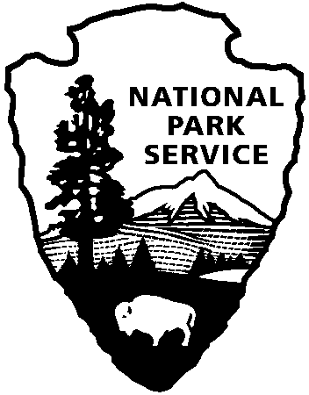
National Park Service
U.S. Department of the Interior

FOR IMMEDIATE RELEASE
December 2, 2014

National Park Service Directs Lava Beds National Monument to Increase Entrance Fees
TULELAKE, California— Lava Beds National Monument is seeking public comment on possible fee increases in 2015. The current entrance fees have been in place since 2003.

Entrance Type | Current Fee  (since 2003) | Proposed Fee (beginning 2015)
1-7 Day Vehicle Fee | $10 | $20
1-7 Individual Fee (Hiker, bicyclist, horses) | $5 per person | $10 per person
1-7 Day Motorcycle Fee | $5 per person | $15 per motorcycle
Annual Lava Beds Pass | $20* | $40**
 | *Also includes entrance to Crater Lake National Park | **Would also include Crater Lake National Park, Lassen Volcanic National Park, and Whiskeytown National Recreation Area

There will be no change to the $80 National Parks and Federal Recreational Lands Annual Pass or commercial group fees.

Entrance fees will continue not to be charged to persons under 16 years of age, or holders of the following types of passes:

Pass Type | Eligibility
America the Beautiful National Parks and Federal Recreational Senior Pass | $10 lifetime pass for those 62 or older.
Access Pass | Free lifetime pass for U.S. citizens or permanent residents with permanent disabilities.
Military Pass | Free annual pass available to U.S. military members and dependents.
Volunteer Pass | Free annual pass with 250 volunteer hours in participating federal agency.

All NPS units will be observing the following nine Fee Free days in 2015:

January 19 | Martin Luther King Jr. Day
February 14-16 | Presidents’ Day Weekend
April 18-19 | First Weekend of National Park Week
August 25 | National Park Service Birthday
September 26 | National Public Lands Day
November 11 | Veterans Day

Indian Well Campground fees will remain the same, at $10 per night for one of 43 first come first serve campsites accommodating up to eight persons. The fee remains $5 per night with a valid Senior or Access Pass. One reserveable site is available for larger groups of 15-40 people, at $3 per person, per night with a maximum of $60 per night.

“We are committed to keeping the monument affordable to visitors, but we also want to provide visitors with the best possible experience,” said Lava Beds National Monument Superintendent Mike Reynolds. “The money from entrance and camping fees is used to improve visitor services and work on the park’s maintenance backlog as we look towards the 2016 National Park Service Centennial.“

Additional revenue raised by a fee increase would help provide visitor oriented projects. For example, in 2014, entrance fees funded a “Cave Rover” project, which hired, trained and placed a seasonal park ranger and two interns in the caves every day all summer, talking directly with Lava Bed’s visitors about cave safety, geology, history and wildlife. Also in 2014, entrance receipts were used to design and create 4 new educational wayside exhibits on the historic Schonchin Butte fire lookout, which will be placed in the spring. Additional projects which fee dollars funded recently include 20 new educational signs along the Mushpot trail, a new vault toilet at the Schonchin Butte parking lot, a travelling educational ‘trunk’ shared with schools in California and Oregon which meet state education standards as well as an update of the park’s webcam and a wildlife camera found in a cave.

Lava Beds National Monument requests public input into how increased fee revenue would best be used.

Lava Beds National Monument is a strong economic engine for the surrounding area. In 2014, approximately 135,000 park visitors contributed over $5 million dollars to the Klamath Basin economy and supported over 75 jobs related to tourism. Lava Bed’s visitors travel from all over the region, country and world to experience the monument. The fee increase brings additional funds to the Klamath Basin that will be used to implement projects locally in the monument. This fee increase would be part of a larger National Park Service initiative to standardize fees in similar NPS units across the country. The new fees would be implemented in 2015, but that could vary based on public feedback.

A public comment period on the proposed fee increase is open from December 1 through December 31, 2014. The best way for the public to comment is through the special feedback website http://parkplanning.nps.gov/labe. Public feedback will help determine how, or if, the National Park Service directs Lava Beds National Monument to increase fees.
* * *
Lava Beds National Monument, established in 1925, is a land of turmoil, both geologic and historic. Over the last half-million years, volcanic eruptions have created a rugged landscape dotted with diverse volcanic features. Lava tube caves, Native American sites, historic battlefields and a high desert wilderness experience await you!
For more information about visiting Lava Beds National Monument, call 530-667-8113, email labe_interpretation@nps.gov, or go to www.nps.gov/labe.
-NPS-

