DRAFT Floodplain Statement of Findings

tuolumne campground rEHABILITATION pROJECT

yOSEMITE nATIONAL pARK

Recommended:
Cecily Muldoon, Superintendent, Yosemite National Park Date

Concurred:
Forrest Harvey, Chief, Water Resources Division Date

Concurred:
Stacy C. Wertman, Chief, Pacific West Region Office of Safety, Health & Wellness Date

Approved:
Cindy Orlando, Acting Director, Pacific West Region Date

Introduction
The Tuolumne River Comprehensive Wild and Scenic Management Plan Record of Decision (2014) includes an action to replace an existing dilapidated vault toilet (Figure 1) with a new vault toilet (Figure 2). The action would take place within the 100-yr floodplain (1% annual chance of inundation). The purpose of this Floodplain Statement of Findings is to analyze the action in sufficient detail to:
- Provide an accurate and complete understanding of the risks to human health and safety assumed by construction of the vault toilet
- Provide an analysis of the risks to property in the project area and the comparative flood risk among the alternatives.
- Describe the effects on floodplain values associated with the preferred action.
- Provide a description and evaluation of mitigation measures to reduce impacts to the floodplain.

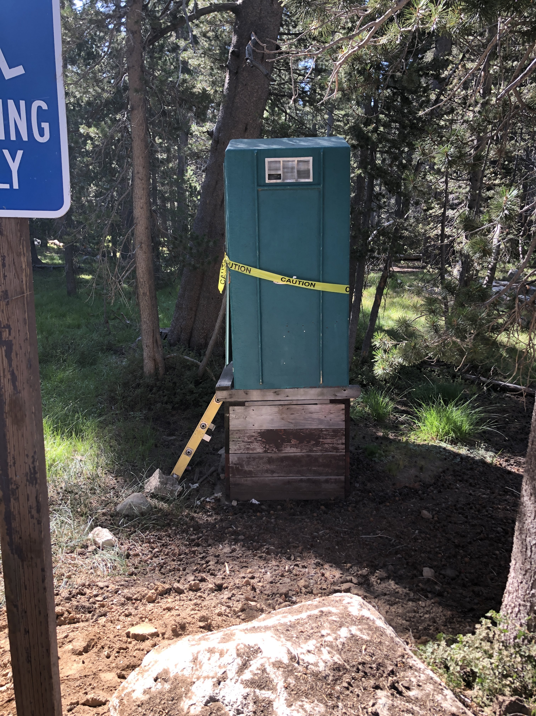

Figure 1. Existing vault toilet
The National Park Service opens this vault toilet in the winter when the Tioga Road is closed to vehicles, snow is on the ground, and the adjacent building becomes a ski hut for overnight use. The vault toilet is the only public restroom available in winter along the 57 miles stretch of the Tioga Road, which becomes defacto wilderness in the winter. The winter rangers lock the toilet when the snow melts but before the road is open. Park maintenance staff pump the toilet when the road opens. The vault toilet remains locked through the spring, summer, and fall until the ski hut opens.
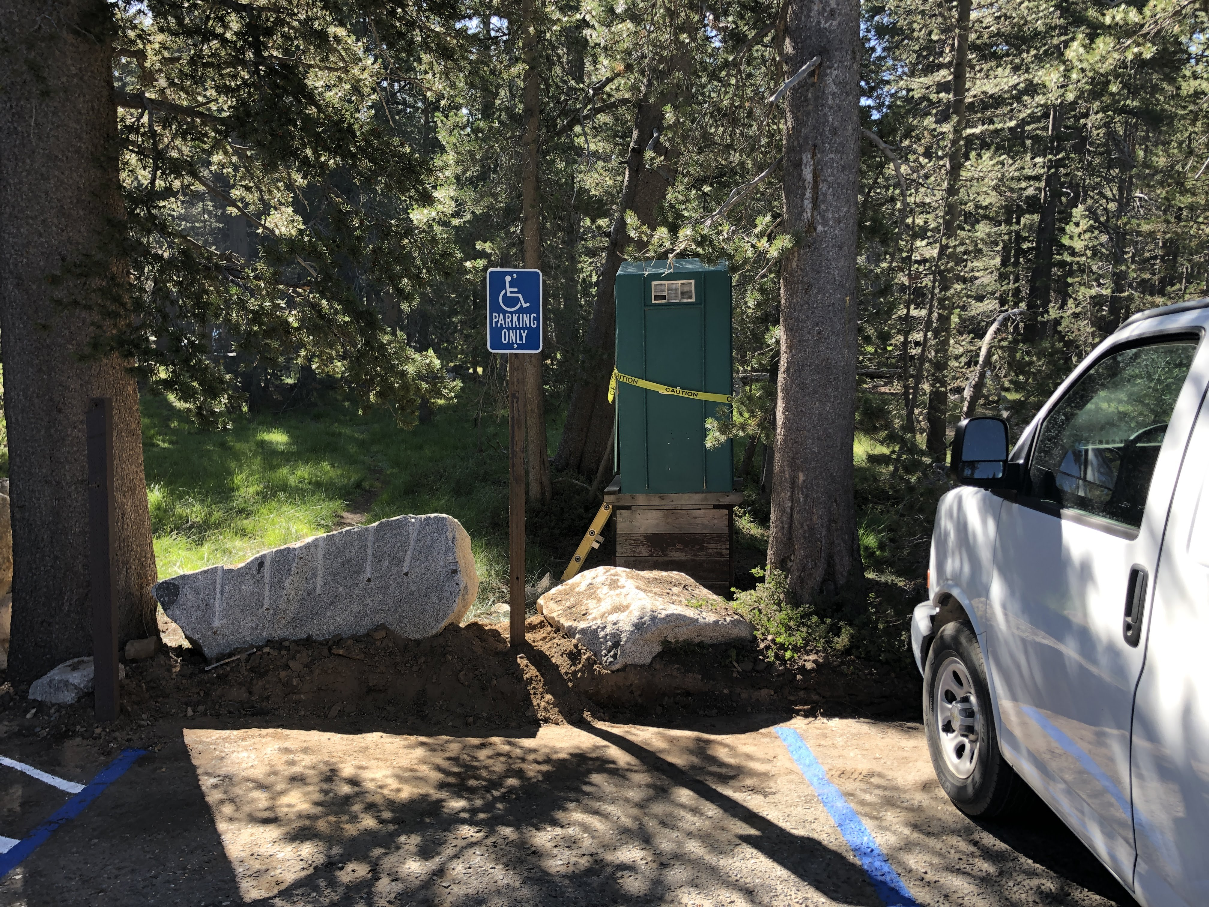
The Regulatory Floodplain for the proposed action at this site is the 100-year floodplain, as described in the NPS Guidelines (NPS Director’s Order 77-2).

General Characteristics of Flooding in the Area
Flooding in the area can be categorized as one of two types: (1) Spring floods that occur with spring and summer snowmelt and associated runoff, and (2) Winter floods or rain on snow events that occur in the late fall and winter during intense rainfall or rainfall on snow events. From 1916 through 1989, 124 of the 140 recorded high flow events in Yosemite were spring floods that occurred in response to spring or early summer snowmelt conditions (Madej et al. 1994). Only about 10% of total floods in the park are winter floods or rain on snow events. These events are responsible for the highest floods recorded, especially where warm heavy rains fall on snow in higher elevations.
An intense storm with a high freezing level may also result in flood runoff from almost the entire basin, with as much as 2 inches of snowmelt augmenting the rainfall by up to 20%, based on historic measurements.

Floodplain Attributes of the Tuolumne River in Tuolumne Meadows
Large floodplains along portions of Tuolumne River have helped create extensive wetland/meadow complexes, such as the one in Tuolumne Meadows. Other portions of the Tuolumne River corridor are steep, with narrow floodplains. The largest documented flood events in Yosemite occurred in 1937, 1950, 1955, and 1997. These floods were the result of rain-on-snow events. Several large undocumented events also occurred during the 1860s and 1870s.

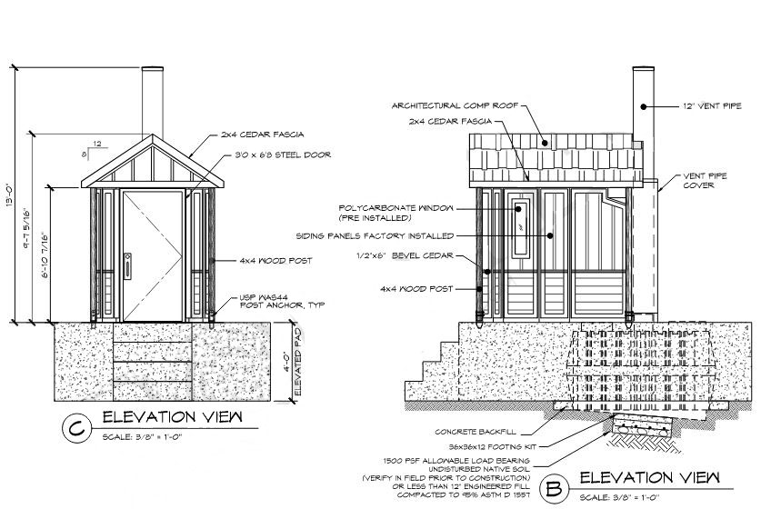
Figure 2. Proposed new vault toilet

potential risks to human health and safety
Floods of consequence in Yosemite always occur with warning. The NPS and other agencies have a comprehensive monitoring system in place to provide an early warning system for major flooding, which provides sufficient time for evacuation.
In addition, visitation to Tuolumne Meadows during flood season is extremely limited. The vault toilet will be locked. When necessary, the NPS will close areas within Yosemite to mitigate risks to human life due to flooding. Early warning, evacuation, and closure of the area would mitigate risks to humans.

potential risks to property
The vault toilet is a Class I Action per NPS Director’s Order 77-2 and Procedural Manual 77-2. Class I Actions include the location or construction of administrative, residential, warehouse, and maintenance buildings and non-excepted (overnight) parking lots, if they lie within the 100-year floodplain. This new vault toilet will be raised above the flood level, to protect the structure from water and flood damage.

Alternatives Considered
Overnight skiers use the vault toilet when staying at the ski hut. Reaching the skier’s hut is a 2-day ski from the west or a 1-day ski from the east for the average skier in good snow conditions. At the hut, skiers or the winter rangers shovel a path through the snow to reach the toilet. The Tuolumne Campground design team considered three alternative locations for the vault toilet (Figure 3): (1) Existing location, (2) near the summer backpackers camp, and (3) Horse Camp. All of the locations are in proximity to a road with access to a pump truck.
The heavily forested campground is rarely traversed on skis in the winter. Most skiers head to the open meadows and high peaks from the ski hut, skiing up and down the Tioga Road to get closer to destinations. Skiers usually hike in boots from the ski hut to the vault toilet, without needing snow shoes or skis. Reaching the Alternative 2 location at the summer backpackers location would require snow shoes or skis. It could take days to shovel a path. It is about a 10 minute ski in good conditions. Reaching the Alternative 3 location at Horse Camp would require snow shoes or skis. It could be a challenging ski in icy or deep snow conditions. Shoveling a path to this location is completely impractical.
The design team considered options 2 and 3 to be impractical. Skiers would not likely use the toilet in the far locations, and the area around the ski hut in the floodplain could become littered with waste. The design team considered Option 1, in the existing location, to be the only viable option.
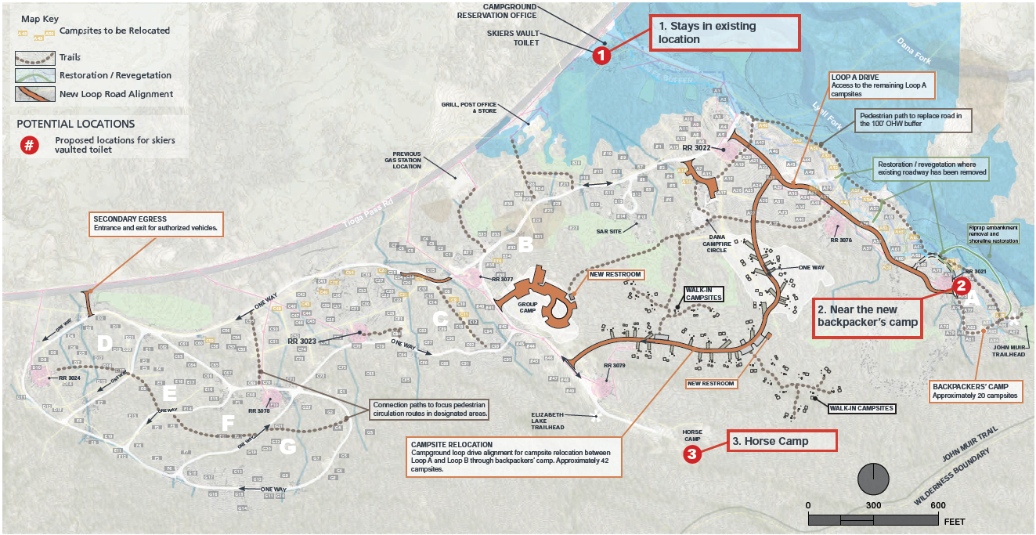
100-yr Floodplain

Figure 3. Three alternative locations considered for new vault toilet placement

potential risks to floodplain values
Floodplains provide an array of natural and physical resource values within Yosemite. These values include habitat for vegetation and wildlife, periodic disturbance to habitats within floodplains, which can support ecological value and spatial diversity in habitat, dissipation of flood energy, and benefits to waterway hydrologic processes including fluvial transport mechanisms and river geomorphic processes. The floodplain also recharges groundwater in areas where soils are sufficiently pervious.
Replacement of the vault toilet with a new vault toilet will protect water-related and other resources from potential leakage from the existing dilapidated toilet. The presence of human waste in nearby natural areas is expected to diminish after replacement with the new toilets.
The footprint of the vault toilet is relatively small in and it is not expected to have a noticeable effect on flood flows. The footprint is not in a riparian or wetland area.

Design or Modifications to Minimize Harm to Floodplain Values or Risks to Life and Property
The design of all new structures or substantial improvements to existing structures will incorporate requirements and methods for minimizing flood damage. Park staff will maintain an active flood evacuation plan. The plan details responsibilities of individual park employees for advanced preparedness measures; removing or securing park property; records and utility systems; monitoring communication; and conducting rescue and salvage operations.

Site-Specific Mitigation
- The vault toilet will be designed with the floor elevation above the height of the 100-yr flood.

Conclusion
Implementation of the preferred alternative in the Bridalveil Fall Rehabilitation Project EA will take place in compliance with regulations and policies to prevent impacts to floodplain values and loss of human life or property. The park and contractors will strictly adhere to mitigation measures during and after construction activities. Individual permits with other agencies will be obtained prior to construction activities. The NPS concludes that there will be no unacceptable risks to human health and safety, unacceptable impacts to property, or substantial long-term adverse impacts to floodplain values. Therefore, the NPS finds the preferred alternative in the Bridalveil Fall Rehabilitation Project EA to be acceptable under Executive Order 11988 and the NPS Directors Order 77-2 for the protection of floodplains.

references
Madej, M. A., W. E. Weaver, and D.K. Hagans
1994 Analysis of Bank Erosion on the Merced River, Yosemite Valley, Yosemite National Park, California, USA. Environmental Management Vol 18, Issue 2, pp 235-250. March.

